EXP. NO: 16
SIMULATION AND ANALYSIS OF UNIFORM AND NON-UNIFORM QUANTIZATION USING MATLAB

MATHLAB CODE:
clc;
clear;
close all;
% Input Signal
t = 0:0.001:1;
x = sin(2*pi*5*t);
% Uniform Quantization (8 Levels)
L = 8;
x_uni = round((x+1)*(L-1)/2);
x_uni = (x_uni*2/(L-1))-1;
% Non-Uniform Quantization (μ-law)
mu = 255;
x_comp = sign(x).*log(1+mu*abs(x))/log(1+mu);
x_non = round((x_comp+1)*(L-1)/2);
x_non = (x_non*2/(L-1))-1;
% Plot Results
figure;
subplot(3,1,1)
plot(t,x)
title('Original Signal')
grid on
subplot(3,1,2)
stairs(t,x_uni)
title('Uniform Quantization')
grid on
subplot(3,1,3)
stairs(t,x_non)
title('Non-Uniform Quantization (\mu-law)')
grid on

WAVEFORM:

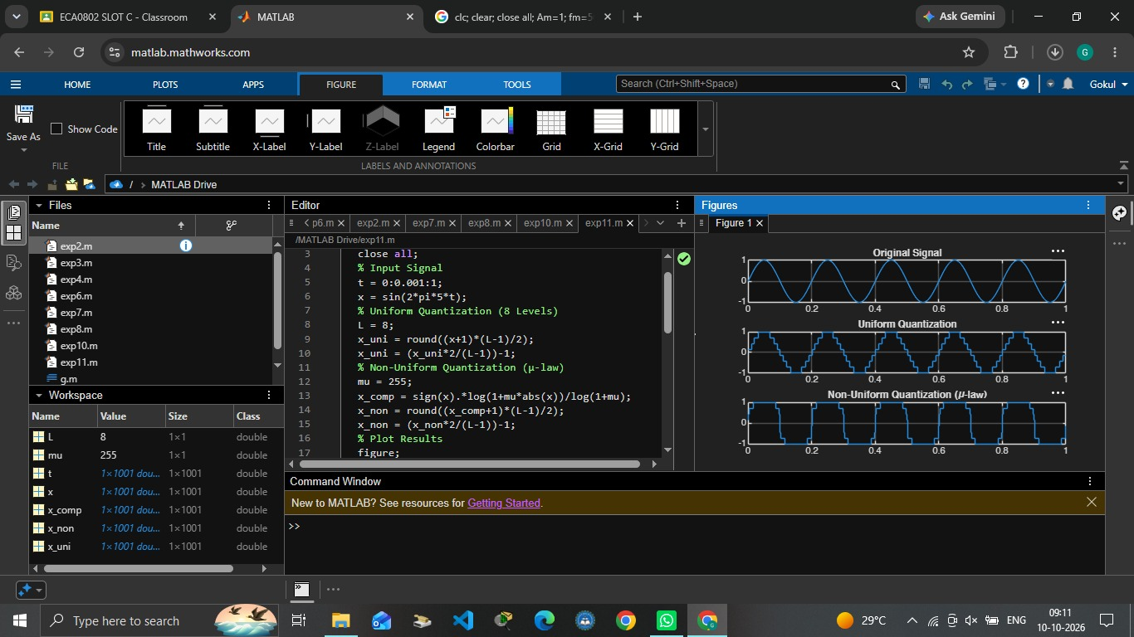

OUTPUT:

